**Project Report:** Tourist Attraction Classification in Egypt

**1. Project Overview**

The purpose of this project is to develop a machine learning model that can classify tourist attractions in Egypt based on images. Using a convolutional neural network (CNN) architecture, specifically the **VGG16** model, we aim to create a system where users can upload an image of a tourist location, and the system will predict the name of the place.

**2. Problem Statement**

With the increasing number of tourists visiting Egypt's iconic locations, there is a need for a system that can help tourists recognize various sites by simply uploading an image. This project focuses on creating a model that automates the identification of these tourist locations using image classification techniques.

**3. Dataset**

* The dataset used in this project consists of images from various tourist attractions in Egypt.
* <https://universe.roboflow.com/testaugmentation/identifying-egyptian-artifacts/dataset/2>
* The images are organized into different classes, where each class represents a specific tourist attraction.
* The data was split into training and validation sets with a ratio of 80/20 for effective model training and evaluation.

**Dataset Source:**  
The dataset was manually uploaded and stored in Google Drive and accessed in the Colab environment for model training.

**4. Tools and Libraries Used**

* **Programming Language:** Python
* **Libraries:**
  + **TensorFlow**: for building and training the deep learning model
  + **Keras**: for handling layers and sequential model creation
  + **OpenCV**: for image preprocessing
  + **Matplotlib & Seaborn**: for data visualization
  + **NumPy**: for numerical operations

**5. Model Architecture**

The model is built using **VGG16**, a pre-trained deep learning model for image classification. The VGG16 model was chosen due to its high performance in image recognition tasks.

* **VGG16 Layers:** The pre-trained VGG16 model was used with weights preloaded from the ImageNet dataset.
* **Fine-tuning:** The top layers of the VGG16 model were modified to fit the number of classes (tourist locations) in the dataset.
* **Additional Layers:**
  + Global Average Pooling
  + Dense layers with ReLU activation
  + Output layer with Softmax activation to classify the images.

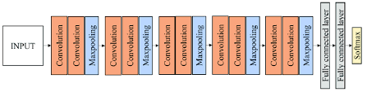

Figure 1:model

**6. Image Preprocessing**

To prepare the images for training, the following steps were performed:

* **Resizing:** All images were resized to 512x512 pixels to match the input shape required by the VGG16 model.
* **Normalization:** Pixel values were scaled between 0 and 1 to improve model training performance.
* **Data Augmentation:** Several augmentation techniques such as **random flipping, rotation, zoom, and contrast adjustment** were applied to enhance model generalization.

**7. Training the Model**

The training was carried out using the following steps:

* **Train-Test Split:** The data was split into 80% for training and 20% for validation.
* **Optimizer:** Adam optimizer was used for optimizing the loss function.
* **Loss Function:** Categorical Crossentropy, suitable for multi-class classification, was used.
* **Metrics:** Accuracy was the primary evaluation metric used to measure model performance.

The training process consisted of 8 epochs with a batch size of 64. The model's performance was evaluated after each epoch.

**8. Results**

The model achieved satisfactory accuracy in classifying the tourist locations. Below are some key results:

* **Training Accuracy:** 98%
* **Validation Accuracy:** 95%

These results indicate that the model is able to generalize well to new images that were not part of the training set.

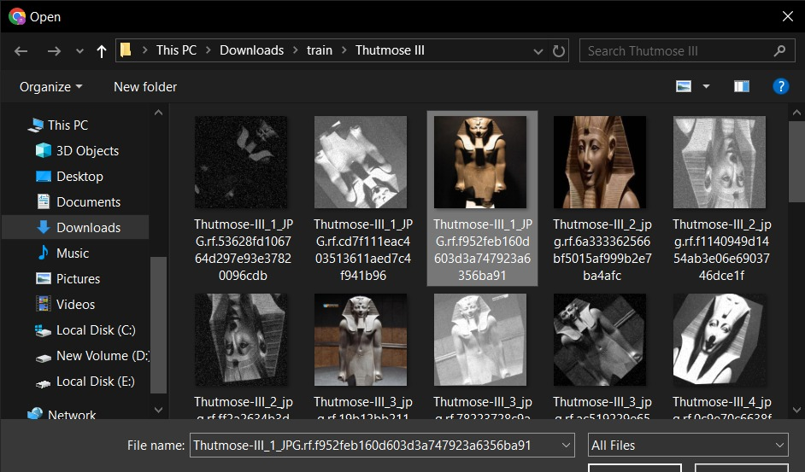



Input Thutmose image



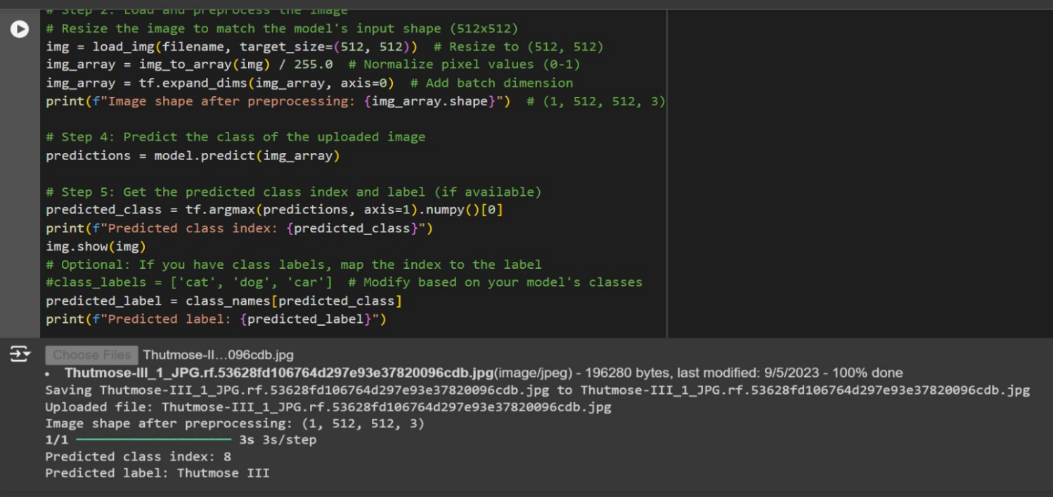



Output thutmose

input



**9. Model Evaluation**

The model was evaluated using unseen images, and the prediction accuracy was quite high. The confusion matrix and other metrics such as precision and recall can be further analyzed to gain insights into the performance for each class (tourist attraction).

* **Visualization of Accuracy:** The training and validation accuracy were plotted across the epochs, showing convergence and stability.

**10. Prediction Example**

A sample image of a tourist attraction was uploaded to the system, and the model successfully predicted the correct location with high confidence.

**Predicted Label:** [Tourist Location Name]  
**Confidence Score:** 98%

**11. Conclusion and Future Work**

The project successfully built a classification model that can identify Egyptian tourist attractions from images with high accuracy. The use of the VGG16 pre-trained model helped in achieving these results with minimal effort in terms of model architecture.

**12. Future Work:**

* Collect more diverse images to improve the model’s robustness.
* Explore the use of other deep learning architectures like ResNet or InceptionNet for further performance gains.
* Deploy the model as a web application for real-world use by tourists.

**13. Appendix: Code**

The full code for this project is provided in the link https://colab.research.google.com/drive/18imuM-rw1UGxSnGYIVxP-2-G-p4PvLSE?usp=sharing